DSP quiz1 Class:_電通三乙____, Student ID:____04242456_____, Name:____李仲朗____

_

1. Generate and plot the following sequences over the indicated interval.

(a) x(n)=3δ(n+2)+2δ(n)-δ(n-3)+5δ(n-7), 

n = [-5:15];

x=3*impseq(-2,-5,15)+2*impseq(0,-5,15)-impseq(3,-5,15)+5*impseq(7,-5,15);

stem(n,x);

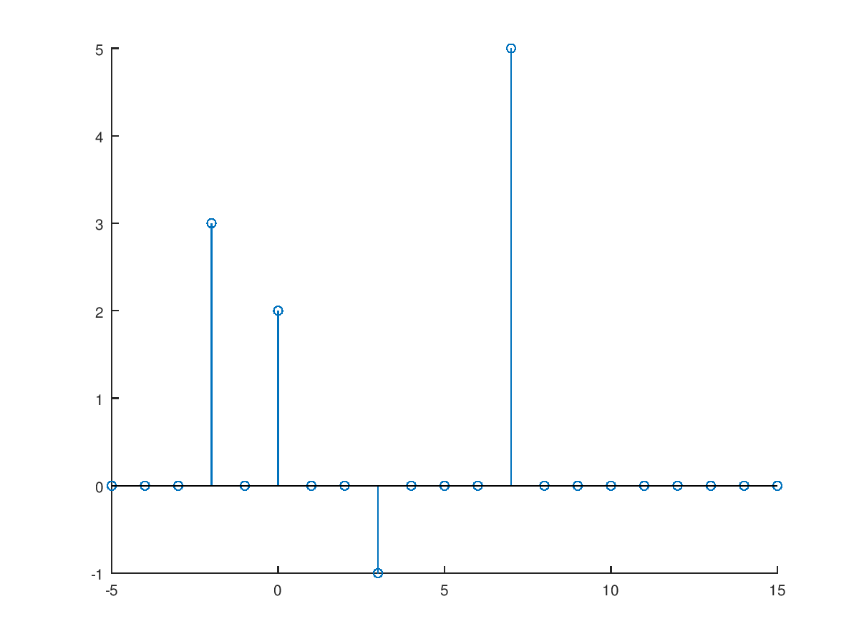

(b) 

close all; clear all;

n=[-200:200];

x=2.*sin(0.01.*pi.*n).*cos(0.5.*pi.*n);

stem(n,x);

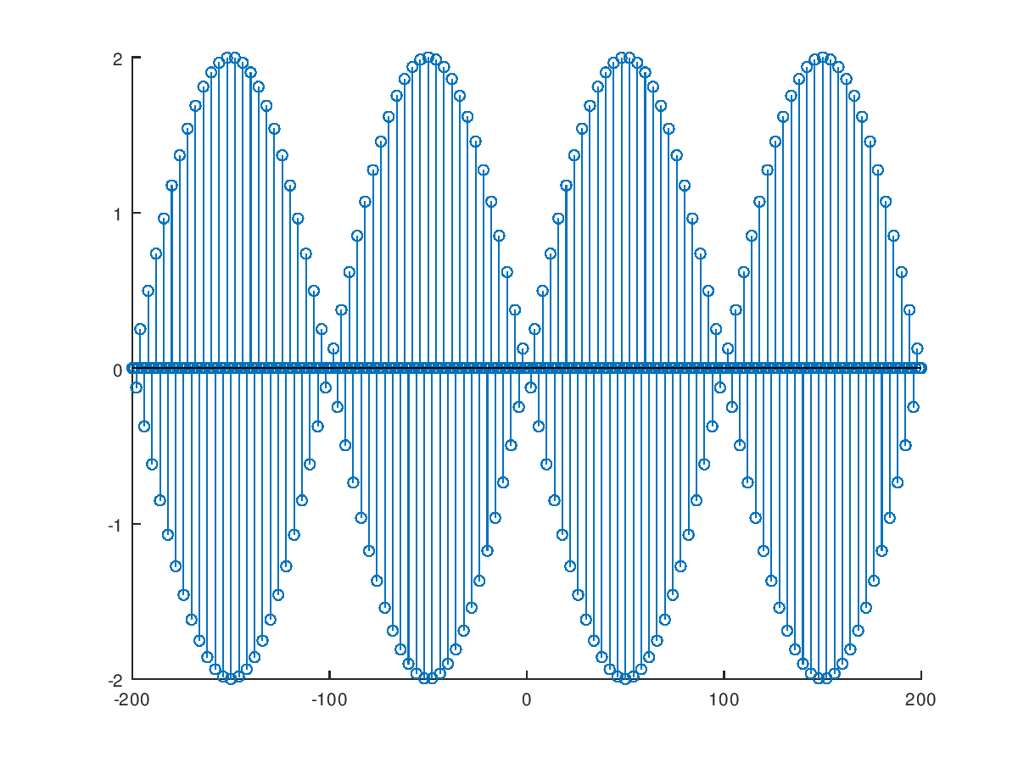

1. Let *x*(*n*)= {2, 4, -3, 1, -5, 4, 7}. Generate and plot the samples (use the stem function) of the sequence: *y*(*n*)=2*x*(*n*-3)+3*x*(*n*+4)-*x*(*n*) ,

n=-3:3;

x= [2 4 -3 1 -5 4 7];

[x11,n11] = sigshift(x,n,3);

[x12,n12] = sigshift(x,n,-4);

[x1,n1] = sigadd(2*x11,n11,3*x12,n12);

[x2,n2]=sigadd(x1,n1,-1*x,n);

stem(n2,x2);

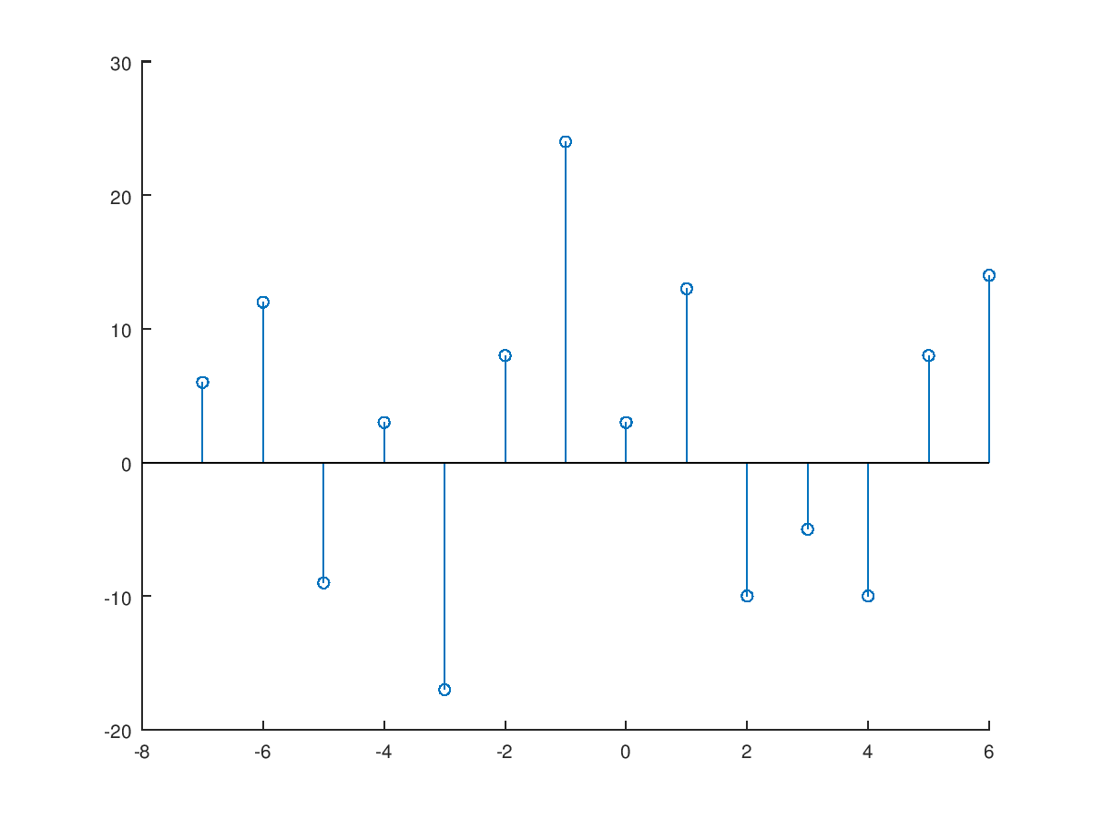

1. (a) Determine whether the following system is linear:

(i), (ii)

(b) Determine whether the following system is time-invariant:

(i), (ii)

4. An LTI system is described by the following difference equation.



* 1. Find and plot the impulse response *h*(*n*) over

b=[1 2 0 1];

a=[1 -0.5 0.25];

[delta,n]=impseq(0,0,100);

h=filter(b,a,delta);

stem(n,h);

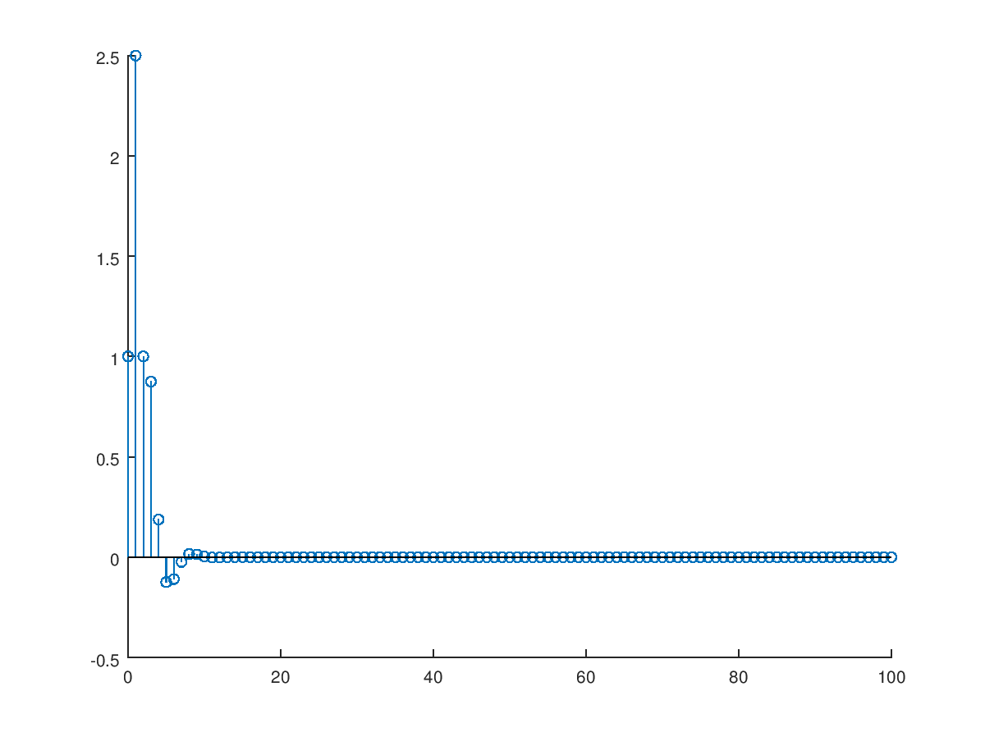

* 1. Is the system stable?

>> sum(abs(h))

ans = 5.8571 ＜[无穷](https://zh.wikipedia.org/zh-tw/%E6%97%A0%E7%A9%B7)

stable

* 1. If the input to this system is determine the response *y*(*n*) over 

b=[1 2 0 1];

a=[1 -0.5 0.25];

n=0:200;

x=5+3*cos(0.2*pi*n)+4*sin(0.6*pi*n);

y=filter(b,a,x);

stem(n,y);

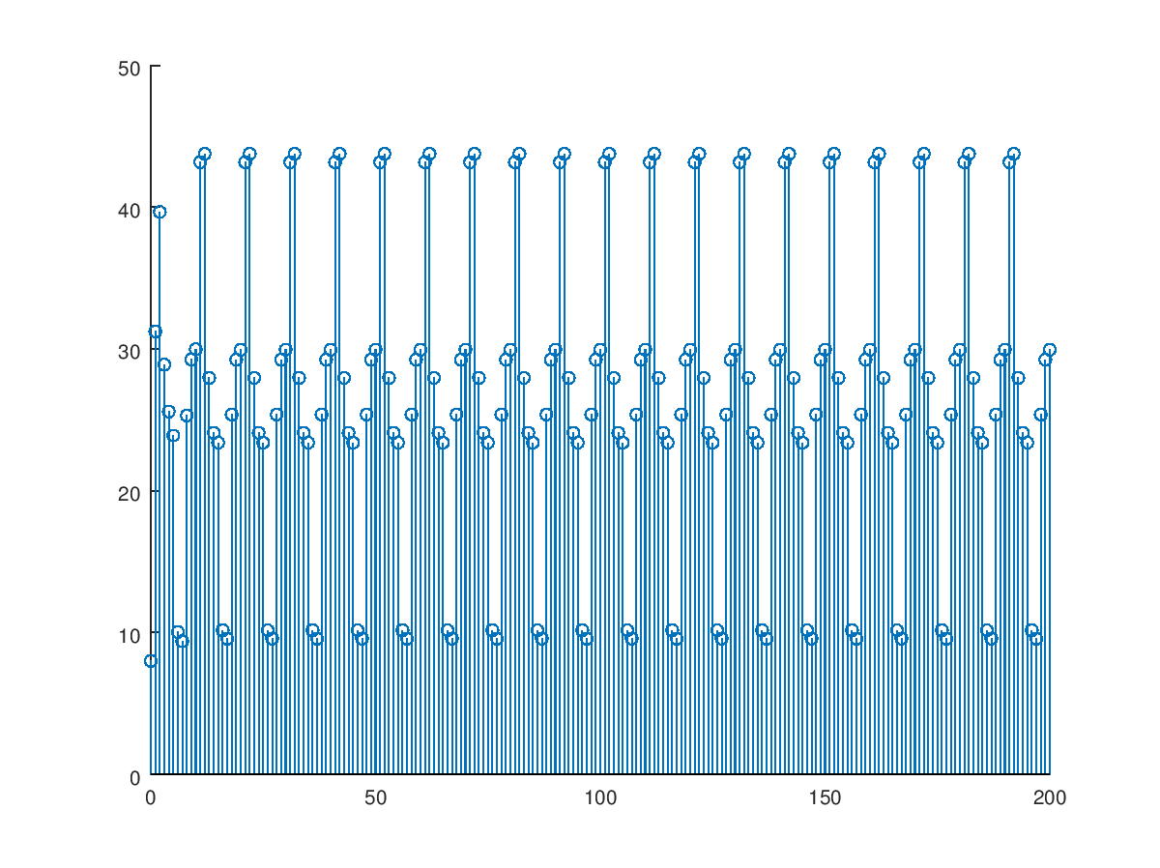

5. Let the rectangular pulse *x*(*n*)=*u*(*n*)-*u*(*n*-10) be an input to the LTI system with impulse response. (a) Determine the output *y*(*n*)=*x*(*n*)\**h*(*n*) by hand, and (b) generate the following figure.

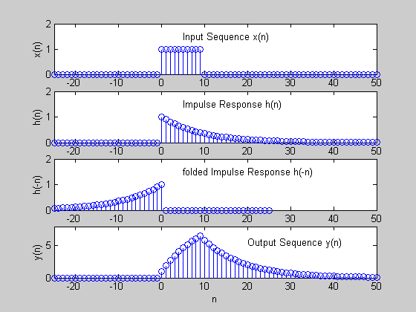

n=-25:50;

x=stepseq(0,-25,50)-stepseq(10,-25,50);

h=((0.9).^n).*stepseq(0,-25,50);

[h1,n1]=sigfold(h,n);

for k=-25:50

if k<0

y(k+26)=0;

elseif k>=0 & k<9

y(k+26)=10*(1-0.9^(k+1));

else

y(k+26)=(10*(0.9)^(k-9))*(1-(0.9)^10);

end

endfor

subplot(411);stem(n,x);

subplot(412);stem(n,h);

subplot(413);stem(n1,h1);

subplot(414);stem(n,y);

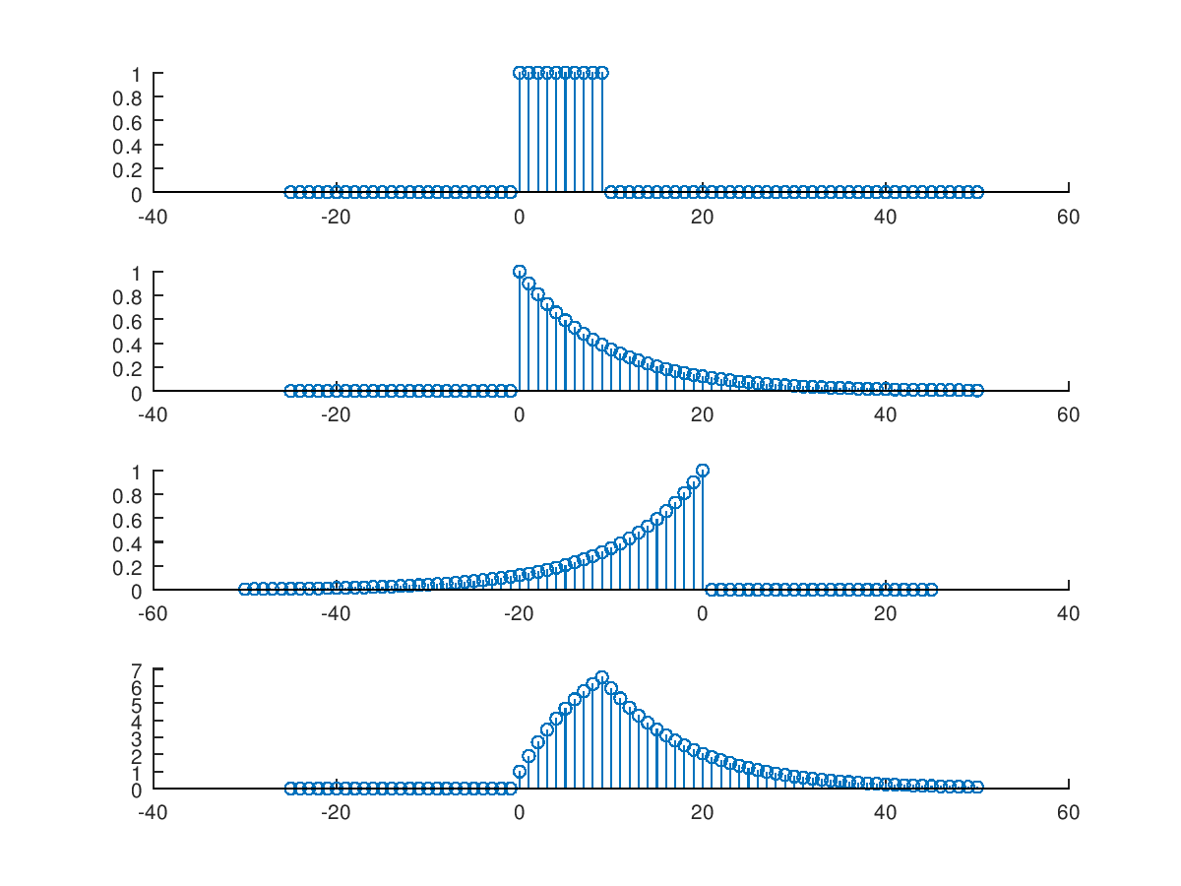

1. Given *x*(*n*)={2, -4, 5, 3, -1, -2, 6} and *h*(*n*)={1, -1, 1, -1, 1}, determine the convolution(a) by using the function conv_m( ), and (b) by hand.

close all; clear all;

x=[2,-4,5,3,-1,-2,6]

h=[1,-1,1,-1,1]

n1=-3:3;

n2=-1:3;

[y,ny]=conv_m(x,n1,h,n2);

stem(ny,y);

